Experiment 14
Simulating & Troubleshooting Network Failures

Lab 14 Objectives:
● Simulate and troubleshoot network failures due to misconfigured IPs or cable issues.
Prerequisites: The prerequisites of this lab are-
● Basic knowledge of networking components (IP addressing, subnetting, physical connections).
● Familiarity with troubleshooting tools and methodologies.

Outcomes: By the end of this lab, students will be able to:
● Identify and resolve IP misconfiguration issues.
● Detecting and troubleshooting network failures caused by physical layer problems.
● Use CLI tools to diagnose and restore network connectivity.

1. Simulate IP Misconfiguration:
Step: Assign an incorrect IP address manually to a system (for example, set it outside the subnet or same IP on two systems).

Expected Outcome: The device will fail to communicate with the network (no internet or local access).

Command to verify:
ipconfig (Windows)
ifconfig (Linux/macOS)
ping [gateway IP]

Common Issues Identified:

IP conflict (same IP on two devices)
Wrong subnet mask
Missing or incorrect default gateway

2. Simulate Physical Layer Failure:

Step: Disconnect the Ethernet cable or use a damaged/faulty cable.
Expected Outcome: The system will lose connection to the network.
Verification Steps:
- Check network icon (shows no internet or disconnected)
- Use ipconfig or ifconfig to see if the interface has an IP.
- Try to ping the default gateway – it will fail.
- Use a cable tester or replace the cable.

3. Troubleshooting using CLI Tools

Using ipconfig / ifconfig:
- View current IP address, subnet, and default gateway.
- Detect if the IP is in the correct range or is assigned as 169.254.x.x (automatic private IP – indicates DHCP failure).

Using ping:
- Test connectivity to:
  - Local gateway: ping 192.168.1.1
  - External host: ping google.com

Using tracert / traceroute:
- Trace the path to a host to see where the connection fails.

4. Fixing the Issues:

IP Configuration Fixes:
- Assign correct IP, subnet mask, and default gateway manually or enable DHCP.
- Example (Windows):
ipconfig /release
ipconfig /renew

Cable Fixes:
- Reconnect or replace Ethernet cables.
- Check physical ports and switch/router connectivity.

Documented CLI Outputs (Examples):
Incorrect IP (before fix):
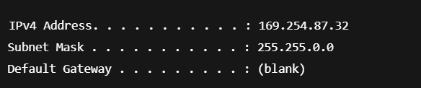

After IP Fix:
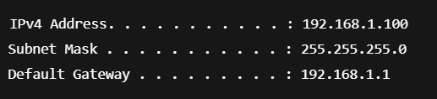

Ping Result:

Summary Report:
Issues Simulated:
- Incorrect IP configuration (wrong subnet, duplicate IP).
- Cable disconnected or faulty Ethernet cable.
Troubleshooting Tools Used:
- ping
- ipconfig / ifconfig
- tracert / traceroute
Problems Identified:
- Device received APIPA (169.x.x.x) address due to DHCP failure.
- Physical layer failure due to unplugged Ethernet cable.
- Network unreachable via ping and traceroute.
Fixes Applied:
- Corrected IP settings using DHCP/manual configuration.
- Replaced damaged Ethernet cable with a working one.

Final Outcome:
All devices were successfully reconnected to the network after identifying and resolving both logical (IP misconfiguration) and physical (cable) issues.

